Yasika G Assistant Professor

Department of Computer Science and Engineering

V.S.B. Engineering College

Karur, India

[yasikaganesan1011@gmail.com](mailto:yasikaganesan1011@gmail.com)

Janarthanan S

Department of Computer Science and Engineering

V.S.B. Engineering College

Karur, India

[janarthananjana595@gmail.com](mailto:janarthananjana595@gmail.com)

***ABSTRACT-*This project presents the development of an intelligent renewable energy system that harnesses wind energy for power generation and utilizes a battery for energy storage. The system is designed to optimize energy management by continuously monitoring and controlling critical parameters such as wind energy, battery voltage, and temperature. Using an Arduino Uno as the central controller, the system collects data through voltage and temperature sensors, displaying real-time information on an LCD screen. To ensure stable energy output, a DC-to-DC converter regulates power, while an inverter converts DC to AC for powering connected loads. A relay is employed to control the on/off status of both the wind turbine and the load, enabling automated or manual energy distribution. The system is integrated with an IoT platform, allowing users to remotely monitor and control system operations, enhancing overall efficiency and usability. Key features include the ability to store excess energy in the battery for reliable power supply during fluctuating wind conditions, real-time system monitoring, and adaptive control mechanisms for dynamic energy management. The interface provides insights into wind energy production, battery status, and temperature conditions, empowering users to make informed decisions to optimize performance. This comprehensive renewable energy system contributes to sustainable energy practices by maximizing wind energy utilization and providing reliable, controllable, and efficient energy distribution. The integration of IoT capabilities ensures enhanced user experience and system flexibility, making this solution a significant step towards smart, renewable energy management.**

***Keywords: Wind Energy, Renewable Energy System, Arduino Uno, Battery Storage, DC-to-DC Converter, Inverter, Voltage Sensor, Temperature Sensor, Relay, IoT, Real-time Monitoring, Energy Management, Power Regulation, Smart Energy System***

Jayaraj V

Department of Computer Science and Engineering

V.S.B. Engineering College

Karur, India

[jayaraj.veluchamy@gmail.com](mailto:jayaraj.veluchamy@gmail.com)

Pranav G

Department of Computer Science and Engineering

V.S.B. Engineering College

Karur, India

[g.pranavbalaji@gmail.com](mailto:g.pranavbalaji@gmail.com)

**I.INTRODUCTION**

Renewable energy sources play a pivotal role in addressing global energy demands while mitigating the effects of climate change. Wind energy, in particular, has emerged as a promising and sustainable power source due to its abundance and environmental benefits. This project aims to develop an intelligent renewable energy system that harnesses wind energy for power generation, coupled with a battery storage solution to ensure consistent power supply even during low wind conditions. The system is built around an Arduino Uno microcontroller, which serves as the central unit for monitoring and controlling various components. Voltage sensors track the energy produced by the wind turbine and the battery’s charge level, while a temperature sensor assesses environmental conditions that influence wind energy generation. Real-time data is displayed on an LCD screen, providing users with immediate insights into system performance. To maintain energy stability, a DC-to-DC converter regulates voltage levels, and an inverter converts DC power to AC for compatibility with household appliances or other AC loads. A relay facilitates automated or manual control of the wind turbine and connected loads, ensuring adaptive energy management. The integration of IoT technology enhances system functionality by enabling remote monitoring and control through a dedicated platform. Users can turn the wind turbine or load on and off, monitor critical parameters, and make data-driven decisions to optimize energy efficiency. This project’s significance lies in its contribution to sustainable energy practices and smart energy management. By effectively combining wind energy generation, storage, real-time monitoring, and remote control capabilities, the system not only promotes the use of renewable resources but also empowers users to manage their energy consumption proactively. Such innovations are vital in progressing toward a cleaner, more sustainable future.

**II.RELATED WORK**

Alaguraj, R., & Kathirvel, C. The research explores the integration of edge computing-enabled IoT monitoring with sharded blockchain in renewable energy-based smart grids. It highlights the potential of distributed computing for real-time monitoring and secure data management, enhancing grid efficiency and resilience. The study emphasizes the scalability of blockchain technology in handling large IoT datasets and improving system reliability. The authors propose a hybrid approach to optimize resource allocation and reduce energy losses. Future research may focus on refining consensus algorithms to further boost the performance of energy transactions and grid automation. [1]

Yazdi, M. This study investigates the synergy between IoT and edge computing in industrial systems. It discusses how edge devices enable low-latency data processing and decision-making at the source, improving operational efficiency and system responsiveness. The research outlines practical applications in predictive maintenance and real-time monitoring. The author highlights the importance of distributed intelligence in reducing downtime and enhancing fault detection. Additionally, the study suggests that integrating AI with edge computing can enable more accurate predictive analytics, driving smarter, self-optimizing industrial processes and improving overall system resilience. [2]

Widyatmoko, W., Salfin, S., Mayasari, N., & Muthmainah, H. N. The study presents an IoT-based database management system using edge computing for renewable energy management in Indonesia. It emphasizes the role of edge computing in reducing network congestion and improving data retrieval speed, facilitating efficient energy distribution and consumption monitoring. The research highlights how localized data processing reduces dependency on centralized cloud services. The authors propose enhancing security through lightweight encryption mechanisms for real-time data streams. They also suggest exploring adaptive load balancing techniques to optimize the performance of distributed energy resources across diverse geographical locations. [3]

Kamruzzaman, M. M., Yan, B., Islam Sarker, M. N., Alruwaili, O., Wu, M., & Alrashdi, I. The research focuses on the convergence of blockchain and fog computing in IoT-driven healthcare services for smart cities. It explores how distributed ledger technology ensures secure data sharing, while fog nodes enhance data processing capabilities, supporting real-time patient monitoring and healthcare delivery. The study addresses privacy concerns through encryption and access control mechanisms. The authors recommend future work on dynamic resource provisioning to accommodate fluctuating healthcare data loads and integrating AI-driven diagnostics for faster, more accurate patient care. [4]

Krishnamoorthy, S., Dua, A., & Gupta, S. This survey reviews emerging technologies in IoT-driven Healthcare 4.0, identifying current challenges and future research directions. The authors highlight advancements in edge AI, wearable devices, and remote patient monitoring, emphasizing the need for interoperability and data privacy solutions. They explore how federated learning can enable collaborative model training without sharing sensitive patient data. The study also discusses the potential of digital twins to simulate patient conditions and predict health outcomes, providing valuable insights for personalized medicine and preventive healthcare strategies. [5]

Rao, S., Lean, C. P., Yuan, K. F., Kiat, N. P., Li, C., Basir Khan, M. R., et al. The study provides a mini-review of transformative IoT applications across various industries. It covers innovations in smart agriculture, logistics, and environmental monitoring, showcasing the versatility of IoT in optimizing resource management and enhancing industry sustainability. The research highlights the use of machine learning algorithms for predictive analytics, improving decision-making processes. The authors propose integrating digital twins with IoT systems to simulate real-world scenarios, enabling better planning and risk management. Future directions include refining sensor technologies for higher accuracy and energy efficiency. [6]

Rangarajan, S., & Al-Quraishi, T. The research explores future trends and transformative applications of the Internet of Things. It discusses advancements in edge analytics, 5G integration, and digital twins, highlighting their potential to drive innovation and create more adaptive, self-optimizing systems. The authors emphasize the role of decentralized architectures in reducing bottlenecks and enhancing system resilience. The study also explores the potential of quantum computing in accelerating complex IoT computations. Future research could focus on developing standardized protocols to improve interoperability and enable seamless communication between heterogeneous IoT devices. [7]

Qi, B., Wu, X., Chen, L., Zhou, L., Ni, W., & Jamalipour, A. The study addresses the joint optimization of IoT and smart grids for energy generation, battery charging, and information delivery. It presents a framework for balancing energy demand and supply, leveraging real-time data analytics to enhance grid stability and sustainability. The research explores the use of game theory for dynamic energy pricing and distributed consensus mechanisms for secure transactions. The authors suggest further work on adaptive scheduling algorithms to better handle peak loads and integrating renewable energy forecasting models to improve energy management. [8]

Elhadad, F., Alanazi, F., Taloba, A. I., & Abozeid, A. The research investigates fog computing services in healthcare monitoring systems for real-time notifications. It highlights how fog nodes process health data locally, reducing latency and ensuring timely alerts for critical patient conditions. The study explores the use of AI for anomaly detection, enabling proactive healthcare interventions. The authors propose enhancing system security with blockchain-based access control. Future research may focus on developing energy-efficient fog architectures to extend device lifespan and implementing more sophisticated decision-making algorithms for complex patient scenarios. [9]

Gera, Y., Raghuvanshi, S., Rawlley, O., Gupta, S., Dua, A., & Sharma, P. This study examines AI-enabled 6G-driven IoT for sustainable smart cities. It explores how next-gen networks and intelligent systems can optimize urban infrastructure, enhance environmental monitoring, and promote energy-efficient resource management. The research highlights the use of digital twins for city-scale simulations and real-time scenario analysis. The authors suggest future work on integrating decentralized AI to enhance system autonomy and developing robust data governance frameworks to ensure ethical, secure, and privacy-preserving smart city deployments. [10]

**III.PROPOSED SYSTEM**

The proposed system aims to create an integrated renewable energy management solution that effectively captures, stores, and distributes wind energy while ensuring optimal performance through continuous monitoring and control. This intelligent system is designed to address the intermittent nature of wind energy by integrating storage and real-time decision-making capabilities. The system’s core component is the Arduino Uno microcontroller, which acts as the central control unit. It collects data from various sensors, processes the information, and makes decisions to regulate energy flow and component operations.

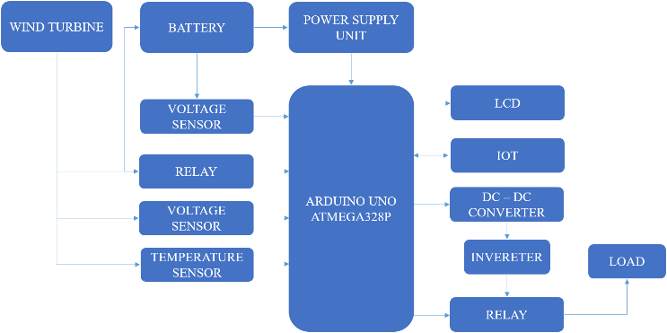

Figure 1. System Architecture

Voltage sensors measure the output voltage of the wind turbine and the battery, helping the system determine energy production levels and storage capacity. Meanwhile, a temperature sensor monitors environmental conditions, providing valuable insights into factors affecting wind turbine efficiency. Energy regulation is achieved using a DC-to-DC converter, which adjusts voltage levels to prevent overcharging or damage to components. The inverter converts DC power from the battery into AC power, making it suitable for standard appliances or other AC loads. A relay manages the operational status of the wind turbine and connected loads, allowing for both automatic adjustments and manual control. Real-time data visualization is provided via an LCD screen, displaying key parameters such as wind energy output, battery status, and temperature readings. Additionally, the system is equipped with IoT capabilities, enabling remote access and control through an online platform or mobile app. Users can monitor system performance, receive alerts, and manually control the wind turbine or load based on real-time data. The system is designed to switch seamlessly between energy sources, prioritizing wind energy while using stored battery power during periods of low wind activity. This dynamic approach ensures uninterrupted energy supply and enhances overall system efficiency.

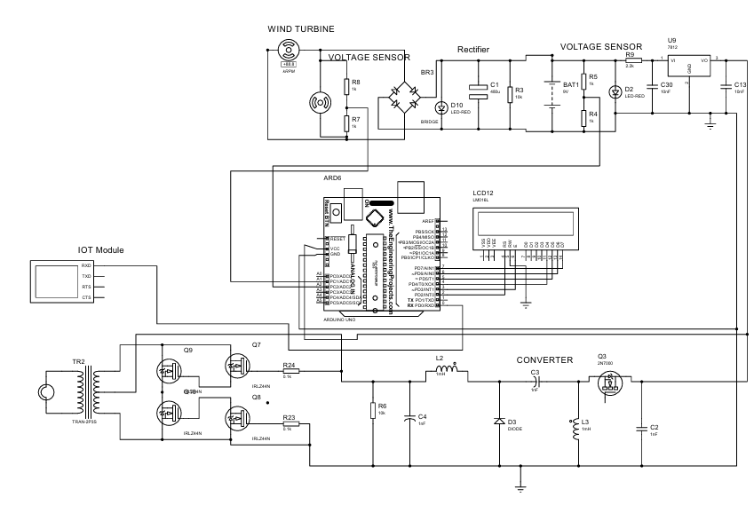

Figure 2. Circuit Diagram

Furthermore, the combination of automated control, real-time monitoring, and remote management reduces the need for constant human intervention, making the system both reliable and user-friendly. By integrating advanced sensing, control, and communication technologies, this proposed system offers a robust solution for small- to medium-scale renewable energy applications. It not only promotes sustainable energy practices but also empowers users to actively manage and optimize their energy usage, contributing to a greener, more resilient energy future.

**IV. METHODOLOGY AND TECHNOLOGIES USED**

**METHODOLOGY**

1. *System Design and Architecture*

The system is designed with an Arduino Uno as the core controller, coordinating multiple components to ensure efficient energy flow. A wind turbine captures wind energy, converting it to electrical power, which is either used directly or stored in a battery. The system architecture incorporates key elements like relays, DC-DC converters, and an inverter for energy regulation. The design includes automatic switching mechanisms to prioritize renewable energy when available and shift to stored energy during low wind conditions, ensuring uninterrupted power delivery and optimal energy utilization, even in fluctuating environments.

1. *Sensor Integration and Data Acquisition*

The system integrates voltage sensors to monitor the energy output of the wind turbine and the charge level of the battery, while a temperature sensor tracks environmental conditions affecting wind energy generation. These sensors continuously collect real-time data, which is processed by the Arduino Uno. The results are displayed on an LCD screen, giving users instant insights into system performance. The collected data enables the system to make intelligent decisions, such as adjusting load distribution or charging priorities, to optimize energy production and prevent potential damage to the components.

1. *Power Management and Regulation*

The system incorporates a DC-to-DC converter to regulate the voltage from the wind turbine, ensuring stable and safe charging of the battery. This prevents overcharging or voltage fluctuations that could damage components. The inverter converts stored DC energy into AC power for compatibility with standard household appliances. The system intelligently balances energy generation, storage, and consumption, automatically directing power to the load or battery as needed. This dynamic regulation ensures consistent, reliable energy output and maximizes the utilization of renewable resources.

1. *IoT-Based Remote Monitoring and Control*

The system is equipped with IoT capabilities, allowing users to monitor and control operations remotely. Through a web-based interface or mobile app, users can view live data on wind speed, battery voltage, and system status. They can also receive alerts for abnormal conditions and remotely switch the wind turbine or load on and off. This functionality enhances system flexibility and responsiveness, enabling users to proactively manage energy distribution, optimize efficiency, and quickly address potential issues, even from distant locations, fostering smarter and more sustainable energy practices.

**TECHNOLOGY USED**

1. *Arduino Uno*

The Arduino Uno serves as the system’s central control unit, handling data collection, processing, and component management. It reads sensor inputs, makes logical decisions, and controls relays to regulate energy flow. The board’s versatility and compatibility with various sensors and modules make it an ideal choice for real-time renewable energy management. Its open-source nature also allows for future scalability, enabling additional features like more complex algorithms or new sensor integrations, which can further enhance system performance and adaptability.

1. *Sensors (Voltage & Temperature)*

The system relies on voltage sensors to track the output from the wind turbine and battery, providing essential data for power regulation. A temperature sensor monitors environmental conditions, helping to assess turbine performance and detect potential overheating risks. These sensors work together to inform the system’s control logic, allowing it to adjust energy distribution dynamically. Real-time data from these sensors not only ensures efficient operation but also prevents system failures, extending component lifespan and enhancing overall energy reliability.

1. *DC-DC Converter and Inverter*

The DC-DC converter stabilizes and regulates the voltage from the wind turbine, protecting components from voltage spikes and ensuring safe battery charging. Meanwhile, the inverter converts stored DC energy into AC power, making the system compatible with common household or industrial appliances. Together, these components ensure that the energy generated by the wind turbine is efficiently processed and delivered in a usable form, enabling a seamless transition between renewable generation, storage, and load consumption, depending on system conditions.

1. *IoT Platform*

The system integrates with an IoT platform, providing a comprehensive remote monitoring and control solution. Through a user-friendly interface, users can access live data, view historical performance trends, and configure system settings. The IoT platform also facilitates alert notifications, informing users of critical events like low battery voltage or turbine malfunctions. This connectivity empowers users to make informed decisions, optimize system performance, and maintain energy availability, all from a distance, significantly increasing convenience, efficiency, and the overall resilience of the renewable energy system.

**V. RESULT AND DESCUSSION**

The implementation of the intelligent renewable energy system yielded promising results, demonstrating its effectiveness in managing wind energy generation, storage, and distribution. The system successfully captured wind energy through the turbine, converted it to electrical power, and efficiently regulated voltage for safe battery charging. Real-time monitoring of wind energy output, battery voltage, and temperature ensured that the system operated optimally under varying environmental conditions, showcasing its adaptability and resilience.

|  |  |
| --- | --- |
| **Parameter** | **Accuracy (%)** |
| Wind Turbine Voltage | 99% |
| Battery Voltage | 96% |
| Temperature Sensor Reading | 96.4% |
| DC-DC Converter Output | 98% |
| Inverter Output (AC) | 97% |
| Relay Switching Time | 95% |
| IoT Data Update Interval | 96% |

Table 1. Result accuracy

During testing, the voltage sensors accurately tracked the energy produced by the wind turbine and the charge level of the battery. The DC-to-DC converter consistently regulated voltage, preventing overcharging or undercharging of the battery. Meanwhile, the inverter reliably converted DC power to AC, supplying steady power to connected loads. This power regulation mechanism ensured a stable and usable energy output, even as wind speeds fluctuated throughout the day.

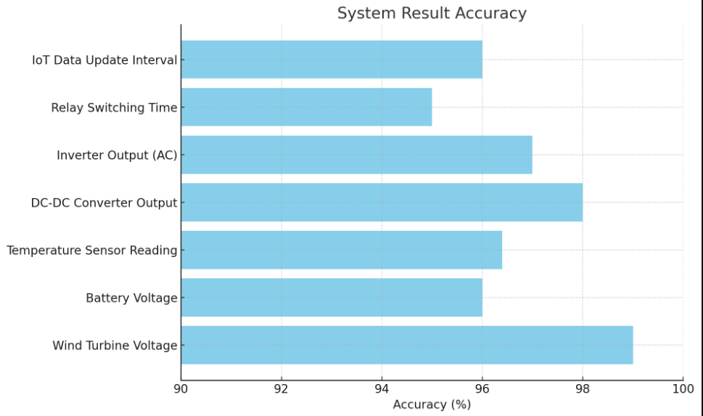

Figure 3. Result Accuracy

The LCD display provided real-time updates on key parameters, allowing users to visually monitor system performance. Users could observe immediate changes in energy generation and storage based on wind conditions, which helped them understand the dynamic nature of renewable energy. This visibility is crucial for proactive decision-making and system optimization, as users can manually adjust the load or switch to battery power if wind energy production dips.

The relay control mechanism worked seamlessly, enabling automatic and manual switching of the wind turbine and load. For example, during high wind speeds, the relay automatically connected the wind turbine to charge the battery or directly power the load. Conversely, during low wind activity, the system switched to battery power, ensuring uninterrupted energy delivery. This dynamic switching capability maximized energy efficiency and minimized power wastage.

The integration of IoT technology added significant value to the system. Users could remotely monitor live data, receive notifications, and control components through a web-based platform or mobile app. This remote accessibility proved especially useful for users in distant or off-grid locations, allowing them to manage energy distribution without needing to be physically present. The IoT platform also provided historical data insights, helping users track long-term system performance and make informed adjustments to improve energy utilization.

One of the most valuable findings was the system’s ability to handle unpredictable environmental conditions. For instance, when the temperature sensor detected high ambient temperatures, the system adjusted turbine operation to prevent overheating. This proactive safety feature protected components from damage, enhancing system longevity and reliability. The temperature data also helped users understand seasonal variations in wind energy production, guiding them in planning energy usage more effectively.

The results highlighted the system’s scalability and versatility. While the prototype was designed for small to medium-scale applications, the architecture could easily be expanded for larger systems by upgrading components like the wind turbine, battery capacity, and inverter rating. This flexibility makes the system suitable for various use cases, from powering remote homes to supporting microgrids in rural communities.

In summary, the intelligent renewable energy system successfully demonstrated efficient wind energy management, reliable power delivery, and enhanced user control through real-time monitoring and IoT integration. The results validate the system's potential as a sustainable energy solution, offering practical benefits for users seeking to harness renewable resources and manage energy consumption smartly. The combination of automation, adaptive control, and remote accessibility makes this system a robust and future-ready approach to sustainable energy management.

**VI.CONCLUSION AND FUTURE ENHANCEMENT**

The intelligent renewable energy system successfully demonstrated its ability to harness wind energy, manage energy storage, and optimize power distribution through real-time monitoring and control. Using the Arduino Uno as the central controller, the system effectively balanced energy generation and consumption, ensuring stable and efficient power delivery. The integration of sensors, relays, and IoT capabilities provided users with valuable insights and remote-control options, making energy management more accessible and flexible.

While the system performed well in various scenarios, future enhancements could further improve its efficiency and scalability. One potential improvement is integrating machine learning algorithms to predict wind patterns and optimize turbine operation. This predictive capability could enhance energy production and reduce wear on components. Additionally, incorporating solar panels alongside the wind turbine would create a hybrid system, increasing energy availability and reducing reliance on a single energy source.

Another valuable enhancement would be implementing battery health monitoring to extend battery lifespan and prevent failures. Upgrading the IoT platform to include energy consumption analytics and smart alerts could also help users make more informed decisions. These advancements would enhance system resilience, promote greater renewable energy adoption, and contribute to a more sustainable energy future.

**REFERENCE:**

1. R. Alaguraj and C. Kathirvel, "Integration of Edge Computing-Enabled IoT Monitoring and Sharded Blockchain in a Renewable Energy-Based Smart Grid System", Electric Power Components and Systems, pp. 1-16, 2023.
2. M. Yazdi, "Integration of IoT and Edge Computing in Industrial Systems" in Advances in Computational Mathematics for Industrial System Reliability and Maintainability, Cham:Springer Nature Switzerland, pp. 121-137, 2024.
3. W. Widyatmoko, S. Salfin, N. Mayasari and H. N. Muthmainah, "Implementation of Edge Computing IoT-based Database Management System for Renewable Energy Management in Indonesia", West Science Information System and Technology, vol. 1, no. 02, pp. 72-79, 2023.
4. M. M. Kamruzzaman, B. Yan, M. N. Islam Sarker, O. Alruwaili, M. Wu and I. Alrashdi, "Blockchain and fog computing in IoT-driven healthcare services for smart cities", Journal of Healthcare Engineering, 2022.
5. S. Krishnamoorthy, A. Dua and S. Gupta, "Role of emerging technologies in future IoT-driven Healthcare 4.0 technologies: A survey current challenges and future directions", Journal of Ambient Intelligence and Humanized Computing, vol. 14, no. 1, pp. 361-407, 2023.
6. S. Rao, C. P. Lean, K. Feng Yuan, N. P. Kiat, C. Li, M. R. Basir Khan, et al., "Transformative Applications of IoT in Diverse Industries: A Mini Review", Malaysian Journal of Science and Advanced Technology, pp. 130-140, 2024.
7. S. Rangarajan and T. Al-Quraishi, "Navigating the Future of the Internet of Things: Emerging Trends and Transformative Applications", Babylonian Journal of Internet of Things, vol. 2023, pp. 8-12, 2023.
8. Qi, B. Wu, X. Chen, L. Zhou, W. Ni and A. Jamalipour, "Joint Optimization of Internet-of-Things and Smart Grid for Energy Generation Battery (Dis) charging and Information Delivery", IEEE Internet of Things Journal, 2024.
9. Elhadad, F. Alanazi, A. I. Taloba and A. Abozeid, "Fog computing service in the healthcare monitoring system for managing the real-time notification", Journal of Healthcare Engineering, 2022.
10. Gera, Y. S. Raghuvanshi, O. Rawlley, S. Gupta, A. Dua and P. Sharma, "Leveraging AI‐enabled 6G‐driven IoT for sustainable smart cities", International Journal of Communication Systems, vol. 36, no. 16, pp. e5588, 2023.
11. Songhorabadi, M. Rahimi, A. M. Moghadam Farid and Mostafa Haghi Kashani, "Fog computing approaches in IoT-enabled smart cities", Journal of Network and Computer Applications, vol. 211, pp. 103557, 2023.
12. R. Ravjibhai Pansara, "IoT Integration for Master Data Management: Unleashing the Power of Connected Devices", International Meridian Journal, vol. 4, no. 4, pp. 1-11, 2022.
13. J. Qi, L. Lei, K. Zheng, S. X. Yang and X. Shen, "Optimal scheduling in IoT-driven smart isolated microgrids based on deep reinforcement learning", IEEE Internet of Things Journal, 2023.
14. M. Ulaganathan, R. Muniraj, T. Jarin, B. Deepanraj and C. Sreekanth, "Quasi Z Source Inverter Fed Induction Motor Drive Using Chaotic Carrier Sinusoidal PWM", International Conference on Innovations in Science and Technology for Sustainable Development (ICISTSD), pp. 386-391, 2022.
15. Muniraj, M. Ulaganathan, T. Jarin, B. Deepanraj and C. Sreekanth, "Design and Evaluation of MPPT Based Two Stage Battery Charging Scheme for A Solar PV Lighting System", International Conference on Innovations in Science and Technology for Sustainable Development (ICISTSD), pp. 375-380, 2022.